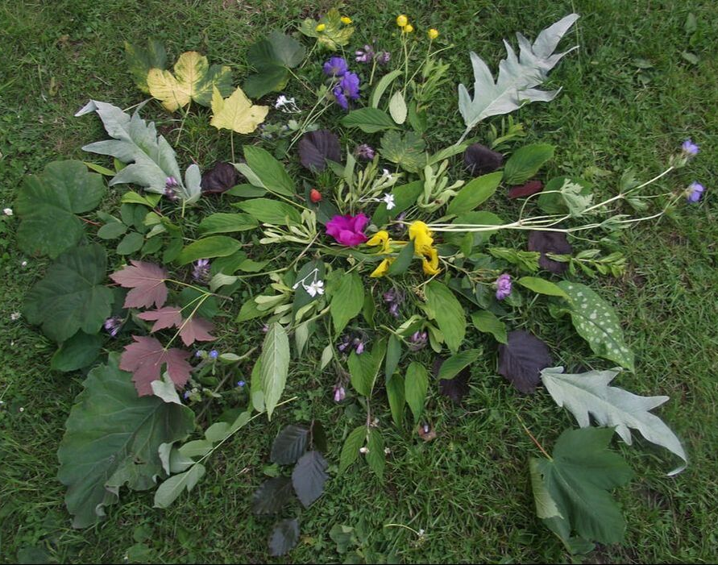

In Memoriam Donations
By Cheque

A donation to the Earthworks Trust, in memory of a loved one, also enables us to continue the important work of The Sustainability Centre. It is a lasting tribute, and one that outlives any cut flowers.
Your gifts are very gratefully received, and will be acknowledged with a personal letter of thanks.

Kindly complete this form and send this information with your cheque.

Donators Name:

Address:

Phone:

Email:

Amount of donation: £

In memory of:

For donations over £50, a short set of words for your ceramic leaf to go on our memorial tree:

